History as an Area of Knowledge

History is an area of knowledge that studies the recorded past. It raises knowledge questions such as whether it is possible to talk meaningfully about a historical fact and what such a fact might be, or how far we can speak with certainty about anything in the past. Studying history also deepens our understanding of human behaviour, as reflecting on the past can help us to make sense of the present.
Documentary evidence plays an important role in history, which raises questions about the basis for judgments of reliability of that evidence. The individual historian also plays an important role in history and in the 20th century there was much debate over whether historical facts exist independently of historians. Some argue that there is always a subjective element in historical writing because historians are influenced by the historical and social environment in which they are writing and this unavoidably affects their selection and interpretation of evidence.

When we DO History in the IB Program, we strive to. . .

Think on 3 levels:

- Acquire historical information
- Do something with it
- Use the information in a new and creative way

When we think this way we will use the following key historical concepts to drive our thinking:

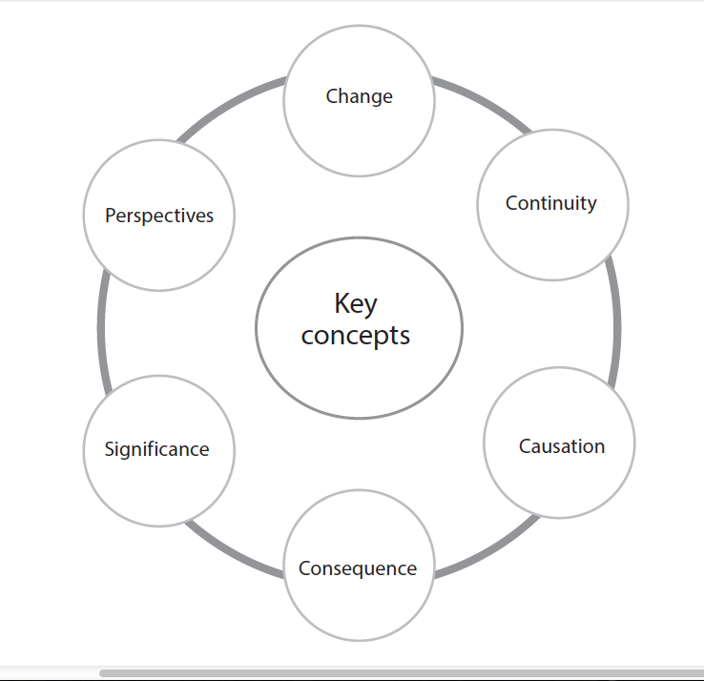

We will also look at what historians have already “done” with historical information. We will study the “history of history.” The study of the discipline of history is called Historiography and includes a body of historical literature that historians have already contributed to. Historiography examines the writing of history and the use of historical methods, drawing upon such elements as authorship, sourcing, interpretation, style, bias & audience

