Instructions for CAS Check in Form (Fall & Spring)

- Log into your Managebac account

- On the “CAS Check In” form (mrskleinberger.weebly.com/cas) list the number of CAS Experiences you have

- On the form, check off for each experience if you have: 1. a reflection and 2. evidence (can be a photo, website, link, document, etc.).

- Take a screenshot of the Learning Outcomes progress bar on the lower right hand side of the page and include on the form. EX:
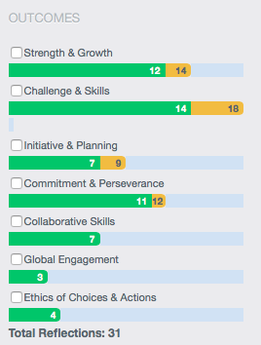

- CAS Project: On the form, explain your project idea (if you have already completed your project, leave this part blank):
  - What is your project? Be specific.
  - Is your project being done individually or as a group?
  - Which strand(s) does your project satisfy?
  - How does/will it satisfy the CAS Stages:
    - Investigation (identifying interests, skills and talents, and areas for personal growth and development)
    - Preparation (determining roles, responsibilities, necessary resources, and an action plan)
    - Action (implementation of the idea or plan to meet the CAS project)
    - Reflection (describing what happened, expressing feelings, formulating ideas, and making connections)
    - Demonstration (make it clearly known what was learned and accomplished)
  - How will your project span one month or more?

CAS Check In Form

Name:
CAS Experiences – you may add rows to the table if necessary

Experience “Title” | Reflection | Evidence

List how many experiences are:
Creativity _________
Activity _________
Service _________

Screen Shot of Learning outcomes {insert here}

CAS Project Questions:
a.

b.

c.

d. (respond in one paragraph)

e.

