Part 2: Presentation
The following diagram shows the question underpinning a global impression judgment of the TOK presentation.
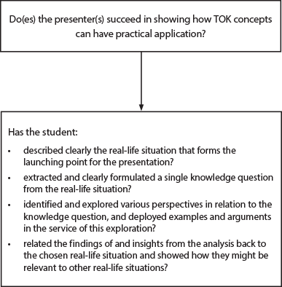

Figure 21

TOK presentation assessment instrument
Do(es) the presenter(s) succeed in showing how TOK concepts can have practical application?
Level 5  Excellent  9–10 | Level 4  Very good  7–8 | Level 3  Satisfactory  5–6 | Level 2  Basic  3–4 | Level 1  Elementary  1–2 | Irrelevant  0
The presentation is focused on a well-formulated knowledge question that is clearly connected to a specified real-life situation. The knowledge question is effectively explored in the context of the real-life situation, using convincing arguments, with investigation of different perspectives. The outcomes of the analysis are shown to be significant to the chosen real-life situation and to others. | The presentation is focused on a knowledge question that is connected to a specified real-life situation. The knowledge question is explored in the context of the real-life situation, using clear arguments, with acknowledgment of different perspectives. The outcomes of the analysis are shown to be significant to the real-life situation. | The presentation identifies a knowledge question that has some connection to a specified real-life situation. The knowledge question is explored in the context of the real-life situation, using some adequate arguments. There is some awareness of the significance of the outcomes of the analysis. | The presentation identifies a knowledge question and a real-life situation, although the connection between them may not be convincing. There is some attempt to explore the knowledge question. There is limited awareness of the significance of the outcomes of the analysis. | The presentation describes a real-life situation without reference to any knowledge question, or treats an abstract knowledge question without connecting it to any specific real-life situation. | The presentation does not reach the standard described by levels 1–5.
Some possible characteristics
Sophisticated  Discerning  Insightful  Compelling  Lucid | Credible  Analytical  Organized  Pertinent  Coherent | Relevant  Adequate  Acceptable  Predictable | Underdeveloped  Basic  Unbalanced  Superficial  Derivative  Rudimentary | Ineffective  Unconnected  Incoherent  Formless

